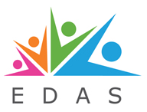
Survival Guide for Parents Sessional Booking Form
session title/s

session date/s

name of attendee/s
contact number for attendee/s

email address
Amount to be paid | £10 per head per date  Total =
Please make payment by one of the following methods:
- By bank transfer to EDAS sort code 40-52-40 Account No. 00089775
Please reference with your name/SG
- By card please provide the following details:
Long card number
Expiry date |  |  |  | /
CSV
Post code that card is registered to:
- By cash at EDAS Serenitea Café please provide a copy of the booking form with the payment.
Have you received course and centre information email? | YES NO

Please complete this form and return it by email to rachel.murphy@edasuk.org

