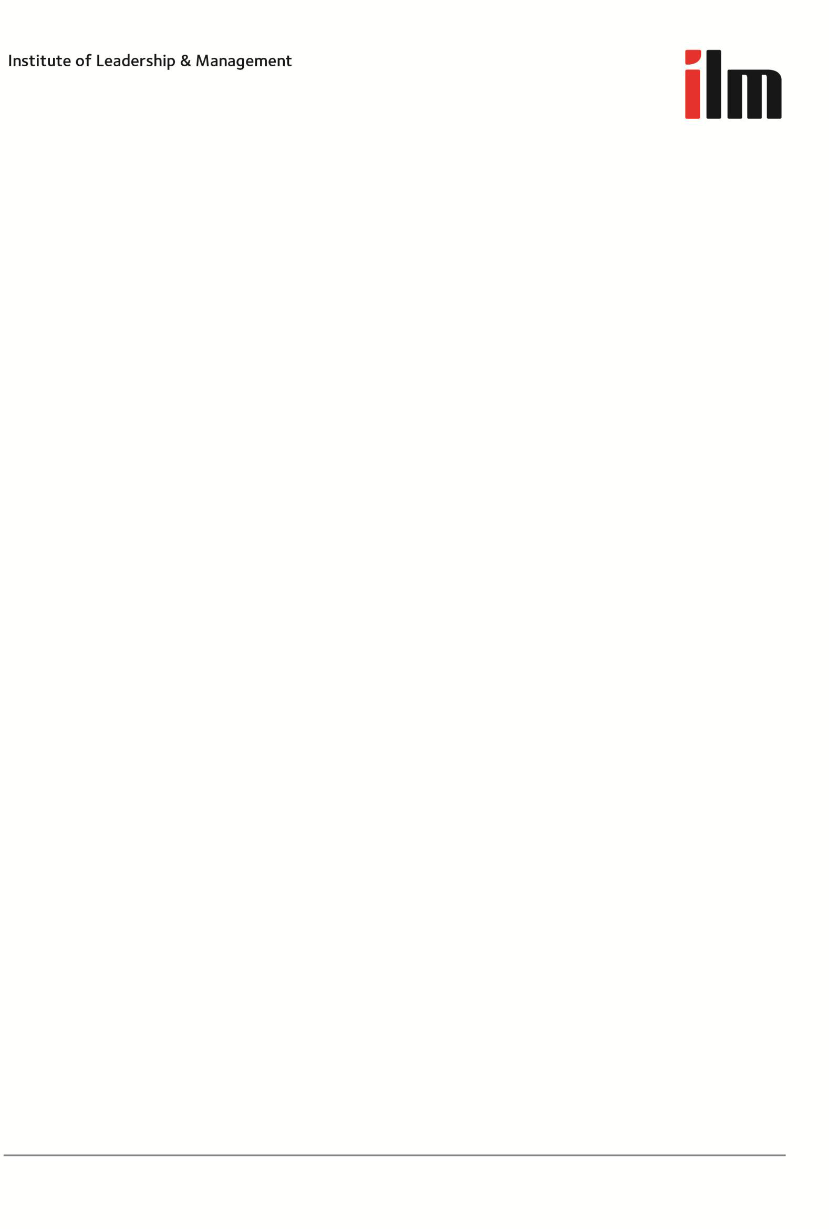

ILM Appeals and Results Enquiry Policy
Revised February 2012

© The Institute of Leadership and Management (ILM) 2012

Table of Contents
ILM Appeals Policy 3
  - Scope 3
  - Definition – appeals 3
  - Out of scope 4
  - Fees 4
  - Process 4
  - Lodging appeals 5
  - Outcome and action 5
  - Escalation 6
  - Continuous Improvement 6
ILM Assessment Marks Enquiries Policy – Subset Appeals 7
  - Scope 7
  - Definition – enquiries 7
  - Out of scope 7
  - Lodging enquiries 7
  - Outcome 7
  - Action 8
  - Continuous improvement 8

ILM Appeals Policy

Note: This policy replaces the Appeals policy contained within the ILM Centre Manual – October 2010 (Reference: section 6.2)

Scope

This policy applies to all centres and providers offering ILM regulated qualifications (e.g. VRQs, NVQs, SVQs), endorsed programmes and other non-regulated products (e.g. IQUALS, FAMP) and, within ILM, our External Verifiers undertaking training to be licensed for one of our products.. The policy provides definition and examples of appeals which may occur for centres, providers, learners or, internally, to ILM External Verifiers. The process for making appeals is described – although we expect a learner to exhaust their centre or provider’s process before referring to ILM.

This ILM policy is provided for two purposes – to guide you in how to approach ILM as well as to provide centres and providers with an example of how you might develop and structure your own policy statement.

Definition – appeals

Appeals may be made against a range of issues relating to ILM qualifications and assessment:
    - Results of assessments – decisions made by the centre and/or ILM
    - Assessment marking – where the result is undisputed and only the percentage mark is questioned – carried out by the centre and/or ILM. This does not include arithmetical errors in marking, which fall under the Enquiries Policy.
    - ILM’s decision to decline a centre’s request for reasonable adjustments, special considerations and/or use of language (other than English)
    - ILM’s actions to be taken following an investigation into malpractice, maladministration, plagiarism and/or cheating
    - The degree of match to ILM units/qualifications identified by an ILM mapping or a RPL exercise

Appeals can be made regarding the results of:
    - ILM qualifications assessed by the centre – VRQs, NVQs or SVQs
    - ILM assessment delivery services (i.e. ILMA and FAMP)
    - Core training or product licensing assessment for ILM External Verifiers
    - Endorsed or development programmes
    - Examinations or tests

Out of scope

There are some issues we will not investigate – essentially anything:

    - submitted to us more than 30 working days after the date on which the centre notified the learner of the result of their internal procedure, or after completion of an internal appeals procedure. In terms of ILMA 30 working days from when the result has been sent to the centre
    - that took place before ILM received the learner’s registration
    - that is or should be dealt with under an employer’s disciplinary or grievance procedures
    - involving another awarding organisation
    - involving points of law

Fees

There is a charge for re-assessment www.i-l-m.com/fees. If the final decision confirms the original assessment we will refund the re-assessment fee. If the assessment is adjusted then the fee will not be refunded.

Process

As part of the ILM approval process you must have your own policy in relation to appeals. This should detail your internal appeals procedure and the mechanisms to work with learners informally to resolve any problems at an early stage. Full records must be kept of internal appeals, investigations and actions taken to resolve the issue. You should exhaust your own policy before referring to ILM for further guidance.

Your internal appeals procedure must state clearly:
    - the stages in the procedure
    - exactly what can be appealed and any matters out of scope of the procedure
    - exactly who – or which position in the centre – the person wanting to appeal should refer their issue to
    - what form the appeal should be in – for example, letter, pro-forma or email
    - any time limits for lodging an appeal, and the timescale for the centre to respond (generally given in ‘working days’)
    - the objective and independent process the centre will use to investigate and respond to the appeal – possibly an appeals panel, consideration by a named individual, or some other appropriate alternative
    - any support or representation the appellant may bring to the appeal
    - how the centre notifies the appellant of the outcome
    - the written records and evidence the centre keeps, and for how long.

Escalation to ILM can only take place once the centre’s internal appeals procedure has been exhausted. ILM will ask to see evidence that the centre’s internal appeals process has been followed and any records relating to the matter must be submitted when making an appeal.

Lodging appeals

Appeals must be made to the Regulation and Business Improvement Manager by emailing ILMRegulation@i-l-m.com within 30 working days (see above 1.3), clearly stating the grounds for your appeal and all evidence needed for ILM to investigate and form a judgement (e.g., in the case of an assessment appeal, the learner’s submission must be included along with mark sheet(s) and all records of assessment, internal verification and the internal appeal). An independent lead reviewer (e.g. Chief Assessor, Lead Assessor) will be appointed to lead the review and to chair the appeals panel, who will consult with relevant parties e.g. the learner, centre staff, External Verifier, Quality Manager. They may ask for additional evidence from people associated with the appeal. The Panel will comprise a minimum of 2 members of the ILM Quality & Regulatory Group, plus participation by an independent person* who has appropriate competence within the assessment process and the subject matter. The Appeal Panel will make the binding decision on the outcome.

Outcome and action

We will normally provide a response to you within 30 working days – a report on the outcome, but if it is going to take longer we will keep you fully informed.

The appointed Appeals Panel will determine the final outcome and confirm in writing with the centre. If the appeal is upheld, ILM will take the appropriate course of action:

If you feel that ILM has not followed its own published timescales or process then please follow the complaints procedure.

    - Appeals against a centre’s assessment decision on result and/or marks
The lead reviewer will review all relevant evidence, reassess the work and write a short report on the findings. If the appeal is upheld we will amend the centre result and/or marks held on our records and take any further action as appropriate. ILM’s decision will be final and there is no further right of appeal to ILM but taking a regulated qualification may have the right of appeal.

    - Appeals against decision of ILM assessment delivery services on assessment result and/or mark Where you disagree with the result or, even if you agree with the result but think the marks awarded by ILM should be higher, for a fee you can ask us to have that submission independently re-assessed by using a different ILM Lead Assessor.

The lead reviewer will then review all relevant evidence, including the original assessment and QA records alongside the new re-assessment, and write a report on his/her findings. The report will be presented to a convened Appeals Panel, which is a subgroup of ILM’s Quality & Regulatory Group.

If the appeal is upheld we will amend the result and/or marks held on our records, if necessary reissue certificates, and take any further action as appropriate. There is no further right of appeal to ILM but taking a regulated qualification may have the right of appeal. ILM will charge a re-assessment fee for appeals against an ILM assessment decision, see the ILM fees list for details.

*The independent person is defined as someone who has not held a role within ILM for at least seven years.

    - ILM’s decision to decline a centre’s request for reasonable adjustments, special considerations and/or use of language (other than English)
The lead reviewer will review the centres initial application and write a report on the outcome. The report will be presented to a convened Appeals Panel, including the ILM Chief Assessor. The Panel will make the binding decision on the outcome. There is no further right of appeal to ILM but taking a regulated qualification may have the right of appeal.

    - ILM’s actions to be taken following an investigation into malpractice, maladministration, plagiarism and/or cheating
The lead investigator will present the original report, the centre’s appeal and the grounds it was made on and any other supporting evidence to a convened Appeals Panel plus participation by an independent person who has appropriate competence within the assessment process. The panel’s decision is final and there is no further right of appeal except for learners registered on a Scottish Vocational Qualification that is regulated by the Scottish Qualifications Authority (SQA).

    - EVs ILMs decision not to license an external vendor for specific qualifications (or units)

Escalation

Scottish Qualifications Authority (SQA)
The lead reviewer will review the centres initial application and write a report on the outcome. The report will be presented to a convened Appeals Panel, including the ILM Chief Assessor. The Panel will make the binding decision on the outcome. There is no further right of appeal to ILM but taking a regulated qualification may have the right of appeal.

Learners registered on a Scottish Vocational Qualification have further right of appeal to the regulator, the Scottish Qualifications Authority (SQA). There have been no cases to date where this has occurred, however, in order to ensure that learners are aware of this entitlement, we ask that you ensure your induction materials include reference to further appeals to SQA accreditation.

Ofqual
(note: at the time of writing this policy Ofqual had not confirmed their plans for an independent appeals mechanism for vocational qualifications.).

Continuous Improvement

The remit of the Quality & Regulatory Group is to review the outcome of all appeals to identify improvements to ILM processes, procedures, training and development. Where any failures in the assessment process are uncovered, the Group is also responsible for investigating whether other centres and/or learners could be affected and any remedial action required.

We aim to improve our business processes and our responses to customers in the light of learning from the feedback we receive.

This policy shall be the subject of a three year review cycle or as necessary.

ILM Assessment Marks Enquiries Policy – Subset Appeals

Scope

This policy applies only to centres that outsource their assessing to the ILM Assessment (ILMA) service and/or offering ILM examinations marked by ILM, i.e. FAMP. The process for making an enquiry is described – although we expect a learner to follow their centre or provider’s process before referring to ILM.

Definition – enquiries

An enquiry is, in effect, a lower-level appeal covering assessments outsourced to ILMA and ILM’s FAMP examinations. An enquiry cannot be made regarding a disagreement over a result or when you think the mark should be higher. This Enquiries Policy relates exclusively to a mistake in ILM’s marking. Where you have identified, for example, an arithmetical error or omission in the ILM’s marking for a submission, you can ask us to re-check the marks we issued. This could involve checking that all sections of the work had been marked and that the marks were added up correctly.

Out of scope

There are some issues we will not investigate – essentially anything:
    - challenging the result or the marking standard
    - submitted to us more than 30 working days after the date on which the centre notified the learner of their result
    - that took place before ILM received the learner’s registration
    - that is or should be dealt with under an employer’s disciplinary or grievance procedures
    - involving another awarding organisation
    - involving points of law

Lodging enquiries

You must make your results enquiry to the Chief Assessor by emailing ilmassessment@i-l-m.com within 30 days of results being issued, specifying which learner and which piece of ILM assessed work you’re enquiring about. The Chief Assessor will check the marks or will appoint an independent person (e.g. different Lead Assessor) to do so.

Outcome

We will provide a response to you within 30 working days – possibly a brief report on the outcome.

Action

If your results enquiry shows that errors were made in the marking process, we will change the recorded mark and issue a new mark sheet. Re-checking the marks is free of charge, but if you want us to re-assess the work or re-mark test papers, you need to use our Appeals Policy and pay the appropriate re-assessment fee. Please note we won’t return marked test papers, mark sheets or marked assessments to the centre.

Continuous Improvement

The remit of the Quality & Regulatory Group is to review the outcome of all enquiries to identify improvements to ILM processes, procedures, training and development. Where any failures in the assessment process are uncovered, the Group is also responsible for investigating whether other centres and/or learners could be affected and any remedial action required.

